Project Report

Distributed Map Reduce using Master-slave Project

The Department of Computer Science
Arkansas State University
Jonesboro, Arkansas, United States

Class: Distributed Systems
Dr. Hai Jiang
Semester: Spring 2019

Submitted by
Ahmad A. Banisaeed

Abstract

MapReduce is a processing technique and a program model for distributed computing. The MapReduce algorithm contains two important tasks, namely Map and Reduce. Map takes a big data and converts it into smaller chunks of data, where individual elements are broken down into tuples (key/value pairs). Secondly, reduce task, which takes the output from a map as an input and combines those data tuples into a smaller set of tuples. As the sequence of the name MapReduce implies, the reduce task is always performed after the map job.

In this project, the Master connects to a number of slaves, then reads the data from text file. Then, it divide the big data into small chunks based of the number of slaves, then it maps the assigned chunks to corresponding slaves, and then the task. After the slaves finish the assigned tasks, and return the result to the master program, which in turn reduce the result into one big result.

The implementaion of the master program code is based in three threads:

- Listenthread thread: which accepts the connections from slaves.
- Mapthread thread: which divide the data into chunks, and assign tasks to slaves.
- Reducethread thread: which takes the results back from slaves, and combine them to get the final result.

The implementaion of the master program code is based in three threads:

- Connectthread thread: which connect the slave to the master.
- Getworkloadthread thread: which get the workload from the master.
- Dotaskthread thread: which do the assigned task.
- Sendresultthread thread: which return the result to the master.

Implementation:
to run the program:
- First, from the master machine, compile and run the master.c program
gcc master.c -lpthread
./a.out

- Second, from each of the slaves machines, compile and run the slave.c program
gcc slave.c -lpthread
./a.out <master-ip>

Master.c
#include <stdio.h>
#include <unistd.h>
#include <stdlib.h>
#include <string.h>
#include <netdb.h>
#include <sys/types.h>
#include <sys/wait.h>
#include <signal.h>
#include <netinet/in.h>
#include <arpa/inet.h>
#include <pthread.h>
#include <errno.h>
#include <time.h>
#include <sys/socket.h>
#include <fcntl.h> // non-blocking sockets
#include <stdbool.h>
#include <dirent.h>

#define TRUE 1
#define FALSE 0
#define BUFSIZE 1024
#define PORT 8080
#define SA struct sockaddr

// threads
pthread_t listenthread;
pthread_t mapthread;
pthread_t reducethread;

char buffer[BUFSIZE];
char buf[BUFSIZE];
char chunk[BUFSIZE];
char filename[20];
char word[20];
int l; // lenght of filename
int filesize;
int chunksize;
FILE *f;
DIR *d;
struct dirent *dir;

int s = 0;
int sockfd;
int connfd;
int len;
int sockets[10];
int input_fd;
ssize_t ret_in;
int n;
struct sockaddr_in servaddr, cli,address;
int slave_socket[30];
int max_slaves;
int total_slaves = 0;
int activity, i;
int valread;
int sd, max_sd;
fd_set fds;
int optval;
int ret;

int totalcount;
int c;

typedef struct MSG
{
char mbuf[BUFSIZE];
char mword[20];
int mcount;
}MSG;

struct MSG msg;

void error(char *msg) {
perror(msg);
exit(1);
}

void* listento(void* argv) {

for(i = 0; i < max_slaves; i++) {
slave_socket[i] = 0;
}

// socket create and verification
sockfd = socket(AF_INET, SOCK_STREAM | SOCK_NONBLOCK, 0);
if (sockfd == -1) {
printf("Socket creation failed...\n");
exit(0);
}
else {
printf("Socket successfully created..\n");
}

optval = 1;
setsockopt(sockfd, SOL_SOCKET, SO_REUSEADDR, (const void *)&optval, sizeof(int));
bzero(&servaddr, sizeof(servaddr));

// assign IP, PORT
servaddr.sin_family = AF_INET;
servaddr.sin_addr.s_addr = htonl(INADDR_ANY);
servaddr.sin_port = htons(PORT);

// Binding newly created socket to given IP and verification
if ((bind(sockfd, (SA*)&servaddr, sizeof(servaddr))) != 0) {
printf("Socket bind failed...\n");
exit(0);
}
else {
printf("Socket successfully binded..\n");
}

// Now master is ready to listen and verification
if ((listen(sockfd, 5)) != 0) {
printf("Listen failed...\n");
exit(0);
}
else {
printf("Master listening....\n");
}

len = sizeof(cli);
FD_ZERO(&fds);
FD_SET(sockfd, &fds);
max_sd = sockfd;

while(TRUE) {
//add child sockets to set
for (i = 0; i < max_slaves; i++) {
sd = slave_socket[i]; // socket descriptor

// if valid socket descriptor, add to read list
if(sd > 0) {
FD_SET(sd,&fds);
}
// highest file descriptor number, need it for the select function
if(sd > max_sd) {
max_sd = sd;
}
}

// wait for any activity on one of the sockets
activity = select(max_sd + 1, &fds, NULL, NULL, NULL);
if((activity < 0) && (errno != EINTR)) {
printf("Select error\n");
}

// if something happened on the master socket, it's an incoming connection
if(FD_ISSET(sockfd,&fds)) {
connfd = accept4(sockfd,(SA*) &cli, &len, SOCK_NONBLOCK);
if(connfd < 0) {
if(errno == EAGAIN || errno == EWOULDBLOCK)
continue;
}
}

c = TRUE;
printf("Master accept the slave...\n");
printf("Connection accepted from %s:%d socket fd is %d\n",inet_ntoa(cli.sin_addr), ntohs(cli.sin_port), connfd);
total_slaves += 1;

// add new socket to array of socket
for(i = 0 ; i < max_slaves; i++) {
if(slave_socket[i] == 0) {
slave_socket[i] = connfd;
printf("Adding to list of sockets as %d\n",i);
break;
}
}

sockets[s] = connfd;
s += 1;
} // end while
}

void* map_thread(void* argv) {
d = opendir(".");
if(d) {
while( (dir = readdir(d)) != NULL) {
strcpy(filename,dir->d_name);
l = strlen(filename);
if(filename[l-1] == 't' && filename[(l-2)] == 'x' && filename[(l-3)] =='t' && filename[(l-4)] == '.') {
printf("%s\n", filename);
break;
}
}
closedir(d);
}

printf("File Name: %s\n",filename);

f = fopen(filename,"rb");
fseek(f,0,SEEK_END);
filesize = ftell(f);
fseek(f,0,SEEK_SET);
printf("File size: %d\n",filesize);
fclose(f);

chunksize = filesize / s;
printf("Chunk size is %d\n\n",chunksize);
printf("Number of sockets is %d\n",s);
for (int i = 0; i < s; i++) {
printf("Socket %d is %d\n",i+1,sockets[i]);
}

// send chunks to slaves
input_fd = open(filename,O_RDONLY);
if(input_fd == -1) {
perror("open");
}

lseek(ret_in,0,SEEK_SET);
for (int i = 0; i < s; i++) {
bzero(chunk,chunksize);
if ((ret_in = read(input_fd,&chunk,chunksize)) > 0) {
bzero((char *) &msg,sizeof(MSG));
strcpy(msg.mbuf,chunk);
strcpy(msg.mword," ");
msg.mcount = 0;
n = write(sockets[i],&msg,sizeof(MSG));
if(n < 0) {
error("Error writing to socket");
}

bzero(chunk,chunksize);
lseek(ret_in,chunksize,SEEK_SET);
}
}

sleep(3);
// map tasks
bzero((char *) &msg,sizeof(MSG));
strcpy(msg.mbuf," ");
strcpy(msg.mword,"cat");
msg.mcount = 0;

for (int i = 0; i < s; i++) {
n = write(sockets[i],&msg,sizeof(MSG));
if(n<0) {
error("Error writing to socket");
}
}
}

void* reduce_thread(void* argv) {
totalcount = 0;
int j = 0;

while (j < s) {
bzero((char *)&msg, sizeof(MSG));

// read the message from slave and get the count
n = read(sockets[j], &msg, sizeof(MSG));
if (n < 0) {
if(errno == EAGAIN || errno == EWOULDBLOCK)
{
continue;
}
} else {
totalcount += msg.mcount;
printf("Count recieved from slave-socket %d for word (%s): %d \n",sockets[j],word,msg.mcount);
j += 1;
}
}

printf("Work to find count of word (%s) done!\n",word);
printf("\nTotal count: %d times!\n",totalcount);

}

int main(int argc, char* argv) {

strcpy(word,"cat");
c = FALSE;

ret = pthread_create(&listenthread, NULL, listento, NULL);
printf("Listenthread thread returns %d\n\n",ret);

while(c == FALSE) {
;
}

sleep(10);
printf("Total slaves = %d\n",total_slaves);

ret = pthread_create(&mapthread, NULL, map_thread, NULL);
pthread_join(mapthread,NULL);
printf("mapthread thread returns %d\n\n",ret);
sleep(3);

ret = pthread_create(&reducethread, NULL, reduce_thread, NULL);
pthread_join(reducethread,NULL);
printf("reducethread thread returns %d\n\n",ret);

//close the socket
printf("\nClosing the connection...\n");
close(sockfd);

return 0;
}

Slave.c
#include <netdb.h>
#include <stdio.h>
#include <stdlib.h>
#include <string.h>
#include <unistd.h>
#include <sys/types.h>
#include <sys/socket.h>
#include <netinet/in.h>
#include <sys/wait.h>
#include <signal.h>
#include <arpa/inet.h>
#include <pthread.h>
#include <errno.h>
#include <time.h>
#include <fcntl.h> // non-blocking sockets
#include <stdbool.h>

#define TRUE 1
#define FALSE 0
#define MAX 80
#define PORT 8080
#define SA struct sockaddr
#define BUFSIZE 1024

int ret;
int sockfd, connfd;
struct sockaddr_in servaddr, cli;
struct hostent *master;
char* hostname;

int tried, connected;
int c;

// threads
pthread_t connectthread;
pthread_t getworkloadthread;
pthread_t dotaskthread;
pthread_t sendresultthread;

int output_fd;
ssize_t ret_out;
char buf[BUFSIZE];
char word[20];
int count;
int task;
int n;

typedef struct MSG {
char mbuf[BUFSIZE];
char mword[20];
int mcount;
}MSG;

struct MSG msg;

void error(char *msg) {
perror(msg);
exit(1);
}

void* connectto(void* argv) {
// socket create and varification
sockfd = socket(AF_INET, SOCK_STREAM | SOCK_NONBLOCK, 0);
if (sockfd == -1) {
printf("Socket creation failed...\n");
exit(0);
} else {
printf("Socket successfully created..\n");
}

// gethostbyname: get the server's DNS entry
master = gethostbyname(hostname);
if (master == NULL) {
fprintf(stderr,"ERROR, no such host as %s\n", hostname);
exit(0);
}

bzero(&servaddr, sizeof(servaddr));
// assign IP, PORT
servaddr.sin_family = AF_INET;
//servaddr.sin_addr.s_addr = inet_addr("127.0.0.1");
bcopy((char *) master->h_addr, (char *) &servaddr.sin_addr.s_addr,master->h_length);
servaddr.sin_port = htons(PORT);

tried = 0;
connected = 0;
while (connected == 0 && tried <= 10) {
// connect the client socket to server socket
if (connect(sockfd, (SA*)&servaddr, sizeof(servaddr)) < 0) {
printf("Connection with the server failed...\n");
tried++;
sleep(1);
}
else {
connected = 1;
c = TRUE;
printf("Connected to the server..\n");
}
}
}

void* get_work_load (void* argv) {
// Get Data
int c = FALSE;
output_fd = open("file1.txt",O_CREAT | O_WRONLY , S_IWUSR | S_IWGRP | S_IWOTH);
if(output_fd == -1) {
perror("open2");
}

bzero((char *) &msg,sizeof(MSG));
while (c == FALSE) {
bzero(buf,BUFSIZE);
n = read(sockfd,&msg,sizeof(MSG));
if (n < 0)
{
if(errno == EAGAIN || errno == EWOULDBLOCK)
{
continue;
}
} else if (n > 0 && (strcmp(msg.mword," ") == 0)) {
strcpy(buf,msg.mbuf);
printf("%s\n",buf);
ret_out = write(output_fd,&msg.mbuf,BUFSIZE);
c = TRUE;
} else {
break;
}
}

// Get Task
bzero((char *) &msg,sizeof(MSG));

c = FALSE;
while (c == FALSE) {
n = read(sockfd,&msg,sizeof(MSG));
if (n < 0)
{
if(errno == EAGAIN || errno == EWOULDBLOCK)
{
continue;
}
} else if (n > 0 && (strcmp(msg.mword," ") != 0)) {
strcpy(word,msg.mword);
count = msg.mcount;
task = 0;
printf("Task recieved: count word(%s) Occurance! \n\n",word);
c = TRUE;
} else {
break;
}
}
}

void* do_task(void* argv) {
int bufsize = strlen(buf);
printf("Buf size: %d \n",bufsize);
int wordsize = strlen(word);
char temp[wordsize];
printf("The word size: %d \n",wordsize);

for(int i = 0; i < bufsize; i++) {
strncpy(temp, &buf[i], wordsize);
if(strcmp(word,temp) == 0) {
count += 1;
i += (wordsize -1);
}
}

bzero((char *)&msg,sizeof(MSG));
strcpy(msg.mbuf," ");
strcpy(msg.mword,word);
msg.mcount = count;
printf("The word (%s) found %d times! \n\n", word, count);
task = 1;
}

void* send_result(void* argv) {
c = FALSE;
while (c == FALSE) {
n = write(sockfd, &msg, sizeof(MSG));
if (n < 0) {
if(errno == EAGAIN || errno == EWOULDBLOCK)
{
continue;
}
} else {
c = TRUE;
printf("Result sent to Master! \n");
}
}
}

int main(int argc, char** argv) {

hostname = argv[1];

ret = pthread_create(&connectthread, NULL, connectto, NULL);
pthread_join(connectthread, NULL);
printf("connectingthread thread returns %d\n",ret);
sleep(3);

ret = pthread_create(&getworkloadthread, NULL, get_work_load, NULL);
pthread_join(getworkloadthread, NULL);
printf("getworkload thread returns %d\n",ret);
sleep(3);

ret = pthread_create(&dotaskthread, NULL, do_task, NULL);
pthread_join(dotaskthread, NULL);
printf("dotaskthread thread returns %d\n",ret);
sleep(3);

while(c == FALSE) {
;
}

ret = pthread_create(&sendresultthread, NULL, send_result, NULL);
pthread_join(sendresultthread, NULL);
printf("sendresultthread thread returns %d\n",ret);
sleep(3);

// close the socket
printf("Closing the Connection...\n\n");
close(sockfd);

return 0;
}
Output:
Master Machine:
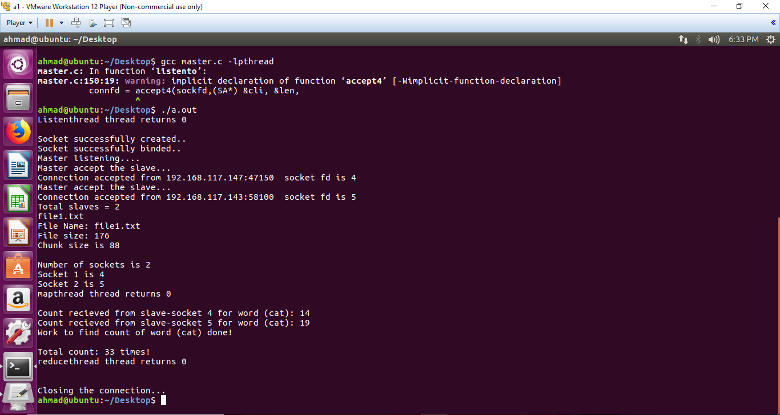
Slave Machine 1:
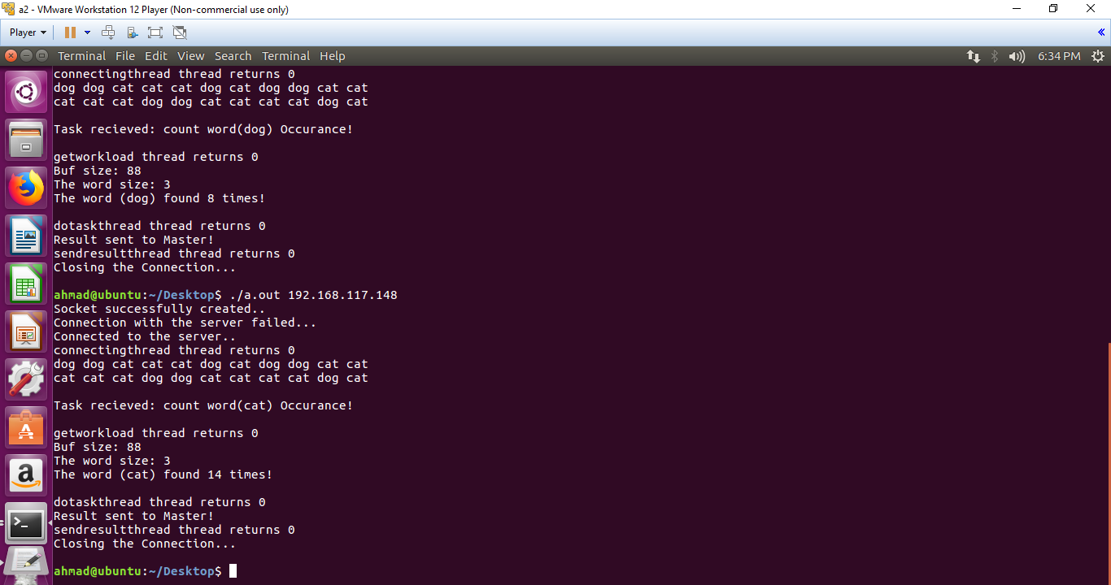

Slave Machine 2:

